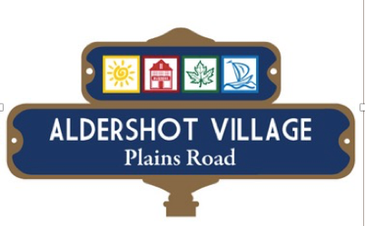

Aldershot Village BIA Board of Directors
Meeting Minutes
Thursday, February 11th 2016

Present: Galbraith, Crook, Diamond, Cook, Galbreath, Mulkewich, Pagliuso, Scharge, Craven

Staff: Dodd
Regrets:
Guests: none

- Call to Order at 7:30
Meeting Chaired by: Kelvin Galbraith

- Approval of Past Minutes – Thursday, January 14th 2015
Motion by: Cook
Second by: Diamond
Motion Carried

- Approval of Agenda: Carried Craven, Crook

- Chairs remarks
- Move to create Letterhead and envelope. Yes.
- John Birch would like us to redo our letter of endorsement on letterhead.
- Crook will get a quote for letterhead from and Aldershot Village business.

- Councilor Craven Report
- Public meeting re: resurfacing biggest issue was traffic.
- Traffic will be disrupted and staff are working on a plan to mitigate the impact along Plains Road.
- ADI has announced the first phase of its Station West development.
- March 7th - 7pm public meeting to discuss Phase One.
- Does not require zoning and bylaw changes so approvals should go through quickly.
- Starts of the discussion of the Mobility Hub.
- Budget has been set for another bench along the Plains Road corridor. Suggestions on where to place it are welcome.
- May 19th we are arranging a walking tour for City Staff and would like 2 representatives of the BIA.
- Met with the Plains Road coordinator for the City of Burlington (Rosa).
- We need to coordinate the walking tour, Strategic Plan with the BIA and the Utilities along Plains Road. This will be added to the Agenda for April.
- Strategic Planning meeting will be planned for June and the Agenda for that needs to be set soon. He will come back with a proposed date.
- April 23rd – Earth Day and are we doing this?

- Social Media Report
- All is flowing nicely. More likes, comments & shares.
- We could use more events from members so another online newsletter will go out reminding members to let us help them with our website.
- One pager for new members was distributed for comments.

- Treasurers Report
- Bookkeeping is being done by Cino Group now and we are ready for the March audit.
- Budget has been revised.
- Craven, Diamond and Galbraith will meet with the City Treasurer to sort out the Bad Debt issue and Councilor Craven will set that up.
- 2016 Budget will be edited and sent by email for approval from Diamond, before the AGM.

- GM Position
- One more interview next Tuesday at 5pm.
- We hope to have the new GM by the AGM.

- AGM – March 10th will stand and Councilor Craven will speak along with financials and a social media report.

- ACHR judging committee – Sonja will attend.

- Meeting Adjourned: 9am, Thank you.

- Next Meeting: Thursday, AGM March 10th at LaSalle, 7:30am.

Please note that all information presented
by Guest Speakers is to be considered confidential.

